CEM 161 Narrative Report – Sorting Commercial Plastics

Introduction

In general, sorting plastics and other materials is an important task in waste management and recycling, since the ability to reuse materials depends on their ability to be purified and be reused by manufacturers to produce new products. In recycling plants, large systems of machines use various physical and chemical processes and techniques to separate materials like plastic for reuse.

In the Sorting Commercial Plastics project, our task was to identify six pieces of plastic by the type of plastic they were made of by making observations on how they differ and matching their characteristics to those of known plastics. Our experiment demonstrates how combining various tests together allows for more precise analysis of materials and demonstrates how separation and recycling of materials can be achieved.

In this narrative report, we discuss the methods used to discover the differences between each material and how we concluded which type each plastic was. We then discuss the accuracy and limitations of our results, as well as how another experiment could achieve superior results using similar methods.

Methods

Our experiment consisted of three goals: finding bounds on density for each material, approximating density by mass and volume measurement, and using IR spectrum matching to support identification.

In theory, density measurement alone can determine each plastic type since each type has no overlap in possible density, however this can lead to incorrect results. We are unable to directly measure density, and must instead approximate volume and divide by mass, which can have varying accuracy. As such, we use approximate density alongside other methods to increase the likelihood of arriving at the correct conclusions.

Goal 1: Density bounds. Using fluids with known densities (calculated and verified in pre-lab), use the fact that dense objects sink bellow less dense ones, we are able to determine if the tested plastic’s density is higher or lower. This test is very accurate for comparing density of each object: for two pieces of plastic where one sinks and the other floats, the former is certainly denser than the latter, and no measurement inaccuracy/error can occur. We prepared solutions of density 0.91-1.14 g/ml using a water/ethanol mixture (1:1) and mixtures of Sodium Chloride in water with various molarities

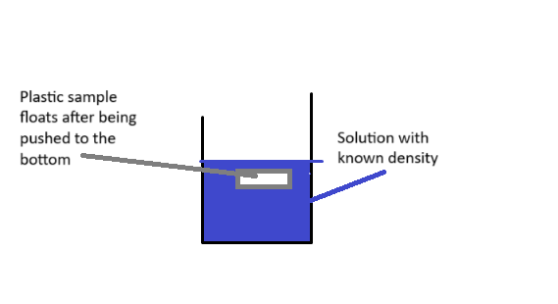

Figure 1: density boundary test. Sample is dropped or pushed down to the bottom of the solution, so as to prevent surface tension from holding it up. It will then sink or float depending on density.

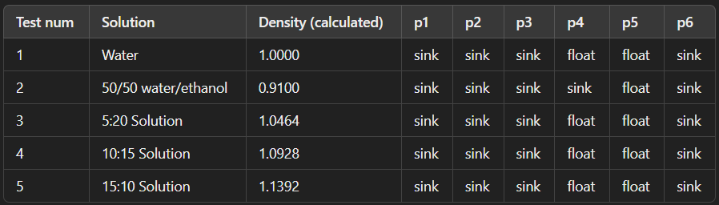

Table 1: results of Goal 1 testing. Samples were labeled as p1-p6 to keep data consistent.

Goal 2: approximate the density from volume and mass measurements. By measuring the volume in a graduated cylinder before and after dropping the plastic in, one can find the density of the plastic by dividing the change in fluid volume by mass. The mass measurement was very accurate 0.001 scale, however the volume measurements were to a limited accuracy 0.1mL, so our samples of volume <1mL could be difficult to read. This can verify the density bounds found during Goal 1 and help identify plastics by providing an initial guess for IR matching. In our results, we show off whether each boundary matched it’s associated approximate density with our conclusion .

Goal 3: IR spectroscopy. We are given the spectrum for each type of plastic, so observing a matching spectrum indicates that the plastic is the same type. Goal 1 will help analyze the spectra by asserting whether or not one plastic is denser than the other, which helps rule out similar appearance spectra with varying mass. From that and initial guesses from Goal 2, we can verify if Goal 2 is accurate.

Results

The full table of our results is shown below

Table 2: material type that is deduced and the density range associated with that plastic is showed besides densities found through measurement.

P4 and p5 had near-identical spectra since they were both Polyethylene. Fortunately these were the same two which had differing cases of sinking/floating, so the lighter one was easily deduced to be p5 – LDPE. P2 did not match any spectra, but between three other possibilities the density matched best with Polystyrene.

During goal #1, we found that plastics would only float in 3 tests involving p4 and p5, in the case of pure water 1 g/mL and water/ethanol 0.91 g/mL. These results are consistent with the measurement-based density and spectrum-based densities. There are cases where the measured density is actually outside the boundary found in the look-up table. For plastics with well-defined IR spectra, this indicates that there is an error in the measurement, either random or systematic.

Nonetheless, the combination of three separate methods to distinguish plastic type allows for gaps in one result to be filled in by another, and for well-described samples to be used to cross-check results. It is unfortunate that so few of the Goal 1 tests yielded useful information on the bounds involved. In another experiment, one may wish to develop solutions with densities near those found in the lookup table or online, so that heavier and denser objects would always indicate the type of the selected plastic. Overall, the whole test could be expanded on by introducing repeat measurements to control random error, and could contain additional sorting methods or high-throughput methods that recycling centers use to separate real plastics.